**Beginner Queries.**

·        Define meta data in mysql workbench or any other SQL tool

·        What is the distribution of order values across all customers in the dataset?

·        How many unique products has each customer purchased?

·        Which customers have only made a single purchase from the company?

·        Which products are most commonly purchased together by customers in the dataset?

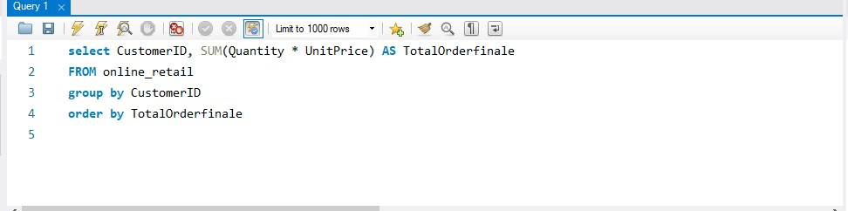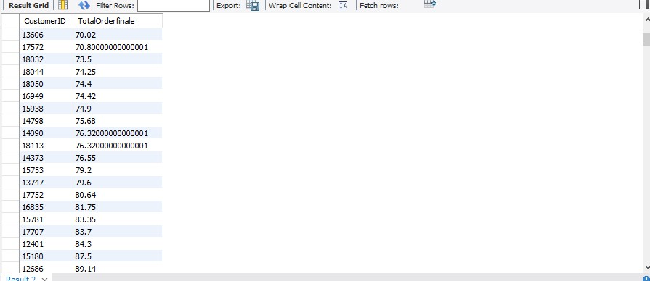

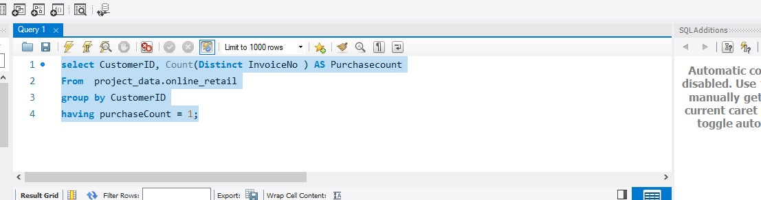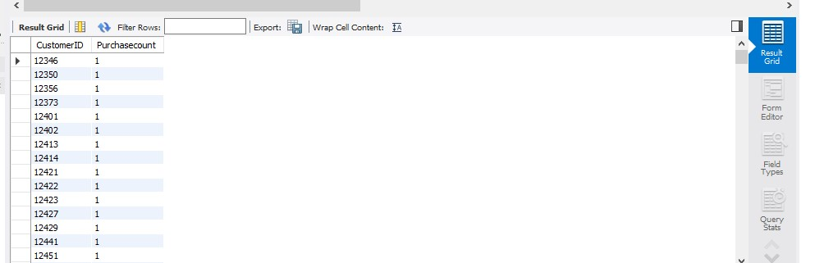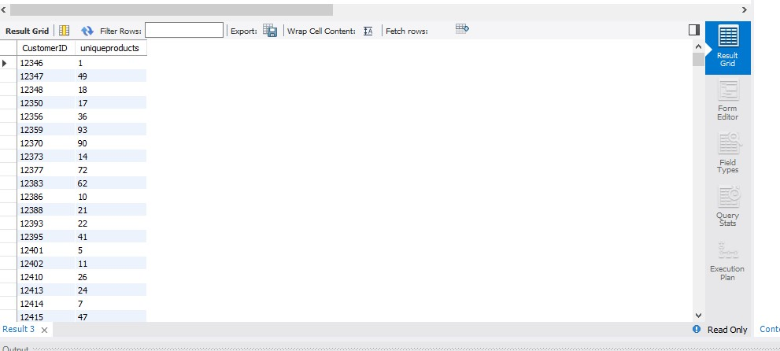

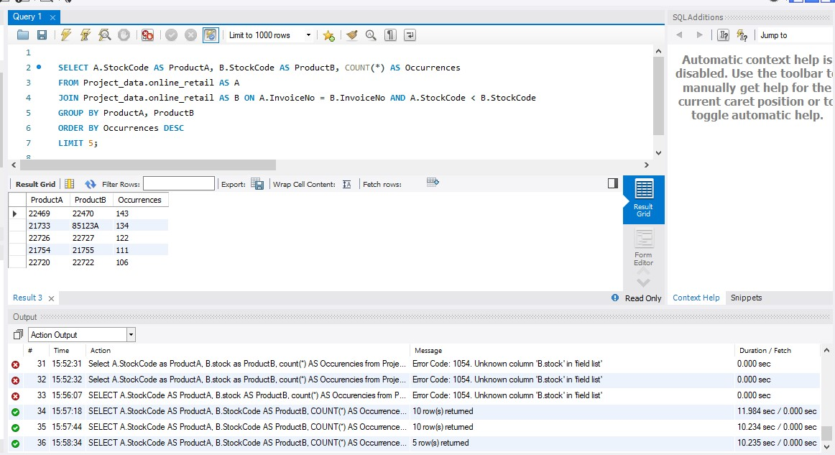

## Advance Queries

**1.      Customer Segmentation by Purchase Frequency**

Group customers into segments based on their purchase frequency, such as high, medium, and low frequency customers. This can help you identify your most loyal customers and those who need more attention.

**2. Average Order Value by Country**

Calculate the average order value for each country to identify where your most valuable customers are located.

**3. Customer Churn Analysis**

 Identify customers who haven't made a purchase in a specific period (e.g., last 6 months) to assess churn.

**4. Product Affinity Analysis**

Determine which products are often purchased together by calculating the correlation between product purchases.

**5. Time-based Analysis**

  Explore trends in customer behavior over time, such as monthly or quarterly sales patterns.

